**LAPORAN PRAKTIKUM PENGOLAHAN CITRA DIGITAL**

**20. PSEUDOCOLOR IMAGE PROCESSING**



**Disusun oleh :**

**Nama : Garcia Bryan Farrel**

**NPM : 2327250026**

**Kelas : IF41**

**PROGRAM STUDI INFORMATIKA**

**FAKULTAS ILMU KOMPUTER DAN REKAYASA**

**UNIVERSITAS MULTI DATA PALEMBANG**

**2024**

**TUTORIAL : PSEUDOCOLOR IMAGE PROCESSING**

**Goal**

The goal of this tutorial is to learn how to display grayscale images using pseudocolors in MATLAB.

**Objectives**

* Learn how to use the grayslice function to perform intensity slicing.
* Learn how to specify color maps with a custom number of colors.

**What You Will Need**

* + grad.jpg
  + mri.jpg

**Procedure**

We will start by exploring the grayslice function on a gradient image.

1. Create and display a gradient image.



1. Slice the image and display the results.

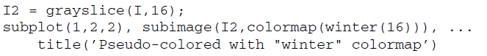

|  |
| --- |
|  |
|  |

**Question 1** Why did we use the sub image function to display the images (instead of the familiar imshow)?

|  |
| --- |
| Dikarenakan fungsi subimage digunakan untuk menampilkan gambar indeks yang menggunakan colormap. Kalau pakai imshow biasanya untuk menampilkan gambar intensitas (grayscale) atau RGB. |

**Question 2** What does the value 16 represent in the function call for grayslice?

|  |
| --- |
| Nilai 16 berarti gambar akan dibagi menjadi 16 level intensitas atau 16 slice warna abu-abu. Sehingga gambar menjadi lebih sederhana dengan hanya 16 tingkat abu-abu |

**Question 3** In the statement subimage(I2,colormap(winter(16))), what does the value 16 represent?

|  |
| --- |
| Nilai 16 di sini berarti jumlah warna pada colormap "winter" yang digunakan adalah 16 warna. Karena gambar I2 memiliki 16 level intensitas jadi perlu colormap dengan 16 warna agar setiap level intensitas bisa dipetakan ke satu wana yang sesuai dalam colormap. |

In the above procedure, we sliced the image into equal partitions—this is the default for the grayslice function.We will now learn how to slice the range of grayscale values into unequal partitions.

1. Slice the image into unequal partitions and display the result.

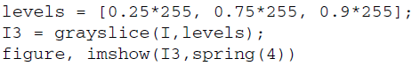

|  |  |
| --- | --- |
|  |  |

**Question 4** The original image consists of values in the range [0, 255]. If our

original image values ranged [0.0, 1.0], how would the above code change?

|  |
| --- |
| Threshold levels harus sebanding dengan rentang nilai gambar. Jika gambar dalam [0,255], threshold juga harus dalam rentang [0,255]. Jika gambar dalam [0,1], threshold juga dalam rentang [0,1]. |

Now that we have seen how pseudocoloring works, let us apply it to an image where this visual information might be useful.

1. Clear all variables and close any open figures.
2. Load and display the mri.jpg.



|  |  |
| --- | --- |
|  |  |

1. Pseudocolor the image.

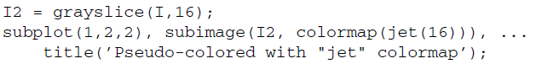

|  |  |
| --- | --- |
|  |  |

**Question 5** In the previous steps, we have specified how many colors we want in our color map. If we do not specify this number, how does MATLAB determine how many colors to return in the color map?

|  |
| --- |
| MATLAB secara otomatis menggunakan jumlah warna yang sesuai dengan colormap aktif saat ini, yaitu jumlah baris dari colormap yang sedang digunakan di figure saat itu. |
|  |